PRESS RELEASE

COMMUNICATIONS AND MEDIA TEAM OF THE 2023 ASEAN SUMMIT

No.08/SP/TKM-ASEAN2023/ENG/4/2023

People's Festivals will Liven Up the ASEAN Summit in Labuan Bajo

Labuan Bajo, 29 April 2023 – The Ministry of Tourism and Creative Economy/Tourism and Creative Economy Agency supports the ASEAN Summit 2023 in Labuan Bajo, East Nusa Tenggara, by presenting a series of people's festivals.

Director of the Implementing Agency for the Labuan Bajo Flores Authority (BPOLBF), Shana Fatina, Saturday, 29 April, said that the people's festivals are a collaboration between the Ministry of Tourism and Creative Economy and the West Manggarai Regency Government.

Activities on the sidelines of the 2023 ASEAN Summit include street carnivals, the Goa Batu Cermin Festival, the SMEs Hub, and several other events.

"This People's Festivals consists of culinary bazaars, music, cultural performances, and fashion shows. The side events are to actively involve the local community, one of which is through the support of the creative ecosystem or MSMEs in Labuan Bajo," said Shana.

Shana said all activities involved the local community with community enthusiasm through creative ecosystems and MSMEs in Labuan Bajo. These ecosystems include local cultural centers, artists, and school students. The hope is that active community involvement will have a positive economic impact on the people of Labuan Bajo.

"This People's Festivals will involve a variety of local cultural content, such as bazaar activities containing various local creative products such as culinary arts, weaving, souvenirs, superior local products such as coffee and rebok sugar, and other handicraft products. Apart from that, specifically, the street carnival will involve a wider range of people, from school students to local cultural centers and local artists through musical performances. Also, we invite performers to entertain the community and delegates," said Shana.

The People's Festivals also presents the ASEAN Youth program by 22 delegation members from ASEAN countries. The participants will carry out a live onboard dialogue with ASEAN Leaders and discussions with local youth to further emphasize the urgency of ASEAN among youth.

This program, said Shana, is in line with the efforts made by BPOLBF in amplifying and educating the people of Labuan Bajo about ASEAN. Promotion and education were carried out through various forms of publication in local, national, and international mass media and digital amplification by disseminating information in Ministries' and Institutions' social media and other social media accounts.

"Apart from that, we also carry out promotions by placing banners at airport entrances, billboards in the Labuan Bajo City area, and backdrop and roll banners for government offices and hotels. We also provide a Tourist Information Center and HelpDesk in the airport and hotel delegations to facilitate information related to Labuan Bajo tourism and activities during the 2023 ASEAN Summit," said Shana.

A series of activities will be in several locations in Labuan Bajo: the Street Carnival at Waesambi Square, the Batu Cermin Cave Festival at Batu Cermin Cave, and the SMEs Hub at the Kampung Ujung Waterfront.

"With the joint commitment of ASEAN member countries to encourage strong and sustainable inclusive, just economic growth, Labuan Bajo as one of the Super Priority Tourism Destinations in Indonesia has also now risen," said Shana. (Ministry of Creative Economy/TR/Elvira)

***

For more information, please contact:

Director General of Public Information and Communications of the Ministry of Communications and Informatics - Usman Kansong (0816785320)

Get other information at https://infopublik.id

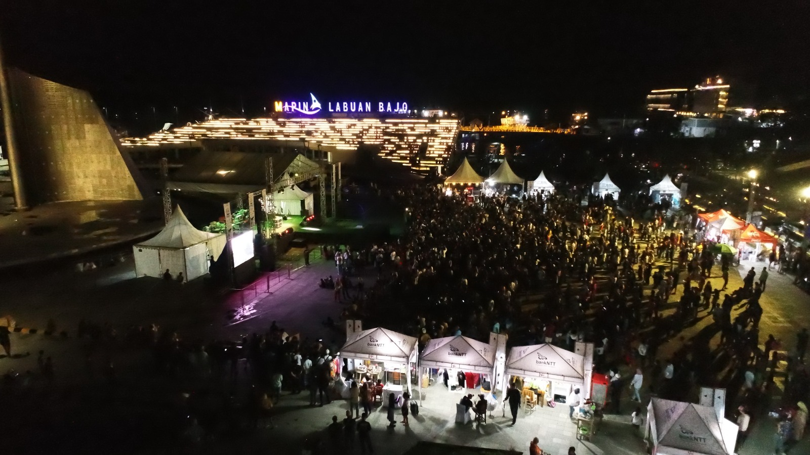

Photo Illustration: Ministry of Tourism and Creative Economy/The festive celebration of the people in Labuan Bajo is ready to welcome the 2023 ASEAN Summit.

